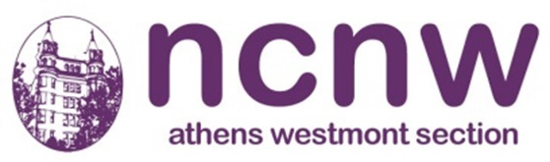 | Athens Westmont Section  Membership Application

NCNW Mission:
NCNW is an organization of organizations that enlightens, inspires and connects more than 2,000,000 women and men. It's mission is to lead, advocate for, and empower women of African descent, their families and communities. Today's NCNW's programs are grounded on a foundation of critical concerns known as "Four for the Future." NCNW promotes education with a special focus on science, technology, engineering and math; encourages entrepreneurship, financial literacy and economic stability; educates women about good health and HIV/AIDS; promotes civic engagement and advocates for sound public policy and social justice.
Click to join us! Or renew your National Dues
Athens Westmont Local dues $60.00 per year
* New members joining AWS-NCNW local dues are prorated as follows:
Oct – Dec $60.00
Jan – Mar $50.00
Apr – Jun $40.00
Jul – Sep $30.00
Payment made Online: Cash App $AthensNCNW
Cash App Customers - Please use the For: field in the app to enter your name and send your application to address listed below or email to: ncnwathenswestmont@gmail.com
Payment made by check or money order:
Send Application to:
Athens Westmont - NCNW, Inc., 309 E. Hillcrest Blvd #190, Inglewood, CA 90301

Member Information
Full Name: |  |  |  |  |  |  |  |  | DOB:
 |  |  | Last |  |  | First |  | M.I.
Address:
 |  | Street Address |  |  |  |  |  |  |  | Apartment/Unit #
 |  | City |  |  |  |  |  | State |  | Zip Code
Phone: |  |  |  |  | Email:
Referred By:

We look forward to you joining this organization of organizations!!

